**Agile Delivery Services BPA**

**RFQ ID: RFQ993471**

**Pool 2**

**Evidence Item: f**

**Continuous Integration**

1. **After code is verified/tested on the QA server, download the entire codebase from GitHub.**

* From this URL: https://github.com/Incatech-Corp/gsa-agile/tree/develop, download the entire code base by clicking on the “Download Zip File” button

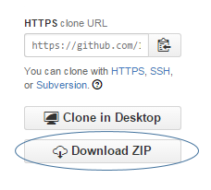

1. **Unzip files to location on local workstation.**

* From Windows Explorer, navigate to the location of the zip file from Step #1
* Right-click on file and choose “Extract All”
* Specify path where you want files extracted (for example, “C:\temp\code_extract\”), then click “Extract”.

1. **Use Java Jar command to create a .WAR file containing all code/files.**

* From the command prompt, navigate to the location of the extracted files from Step #2
* Run jar command against extracted files to create the .WAR file (using our example path from Step 2):



1. **Check .WAR file into GitHub.**

* Move .WAR file to location on local workstation that our GIT client (i.e. SourceTree) will recognize as something that is ready to be checked into GitHub
* Commit .WAR file to GitHub

1. **This check in will initiate an automatic push to the production instance.**

* Using AWS CodeDeploy on Amazon EC2 instance, in conjunction with GitHub Services (listed below), the .WAR file is automatically pushed to the production environment.

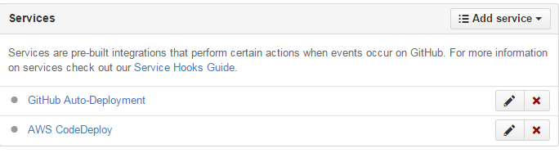

1. **Once the .WAR file arrives on the production instance, it is automatically unpacked and deployed.**

* The production instance URL is: [www.FoodRecall.us](http://www.FoodRecall.us)